[Flow Charts]
[LCCS Project]

Computer Science

TEACHER: Pat Brennan
COURSE: LCCS
ACADEMIC LEVEL: Honors
ACADEMIC YEAR: 2024 - 25
TOPIC: Flow Charts

[The Institute of Education]
[LCCS]

Flow Chart Symbols

Marks the beginning of a program.
Start

Marks the end of a program.
Stop

Used to ‘Read’ in values.
Read Value A
‘Read In’ values means to enter values.

Denotes a process to be carried out.
(G1+G2+G3+G4) / 4

A process might be to add, subtract, multiply, divide etc.

Denotes a decision to be made.
Is grade < 50
If / Then / Else

Denotes an output program
Print
‘Fail’
e.g. Print the result of something
Note: Print here means ‘to show’ or ‘to display’.

Denotes the direction of a logic flow in the diagram

Sample 1  Create a flow chart that sums two number and prints out the result.  Sum of Two Numbers | Sample 2  Create a flow chart that reads in length and width, calculates area and prints out the result.  Area of Rectangle
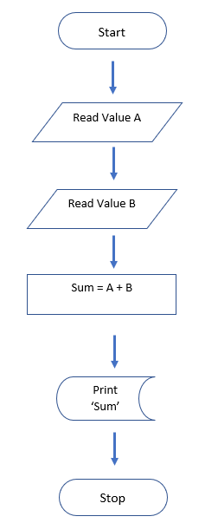 | 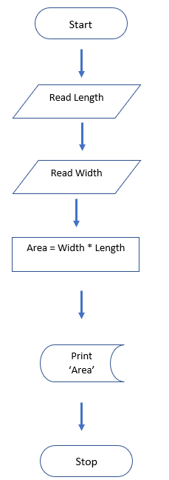

Exercise 1
Create a flow chart that classifies animals as either herbivore {only eats plants} or carnivore {eats meat.}
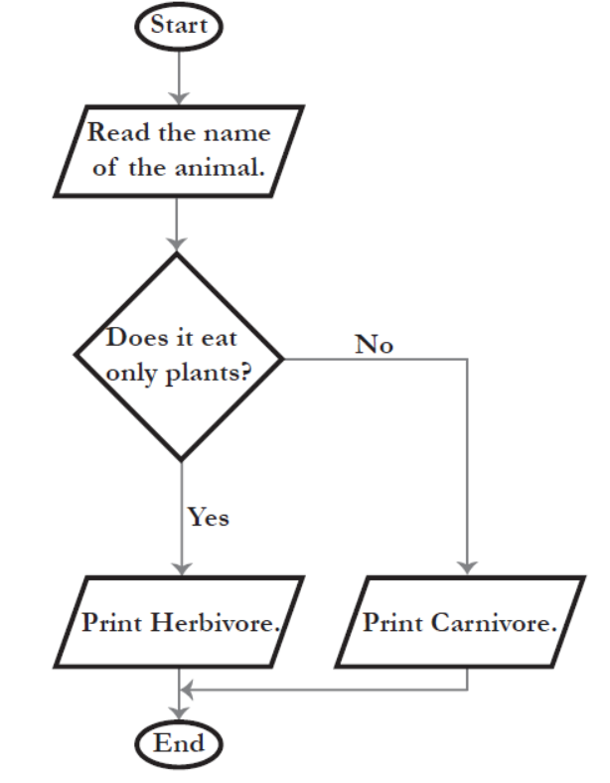

Exercise 2
Draw a flow chart where four grades are inputted and then averaged. If the grade is over 50, the word ‘Pass’ is printed and if it is less than 50, ‘fail’ is printed.
Start
Start Start of operation

Input Grades
Read G1 G2 G3 G4
Note: ‘Read’ means ‘Enter’ value.

(G1+G2+G3+G4) / 4

Process grades to find the average grade

Is grade < 50

No Yes Decision Is the grade less than 50
Yes or No
Print
‘Fail’
Print
‘Pass’

Output If yes (grade < 50) print ‘Fail’ is output
If no (grade is NOT < 50) print ‘Pass’.
Note: ‘Print’ means ‘Display’ or ‘Show’.
Stop End of operation
Stop

Exercise 3
Draw a flow chart that reads in two values (that means where two values are inputted) and displays the largest of the two values.
Start
Start

Input two values
Read Value 1 Read Value 2

Value 1 < Value 2

No Yes Decision Is Value 1 less than Value 2
Yes or No
Print
‘Value 2’
Print
‘Value 1’

Output
If yes (Value 1 < Value 2)
print ‘Value 2 is bigger’.
If no (Value 1 < Value 2)
print ‘Value 1’ is bigger.
Stop
Stop End of operation

Exercise 4
Create a flowchart that shows the process of deciding how to get to school: If you leave home and the time is before 7:00 AM, take the subway; otherwise, take the bus. The flowchart should start with leaving home and end with reaching school.

Start
Start

Input Value A
Time Left Home

Before 7am

No Yes Decision Does Value A divided by 2 give a
remainder.
Take Subway
Take Bus
Yes or No

Output
If yes (Take Subway)

If no (Take Bus)

Stop End of operation
Reach School {Stop}

Exercise 5
A, B and C are the grades of a student for Science, Maths or English.
Draw a flow chart that determines whether the student should be awarded a star (>75) or encouraged to do better. Hint! Average the grades

Start
Start

Input Value A
Read Grade A, Grade B, Grade C

Sum = A + B + C

Average = Sum / 3

Average > 75

No Yes Decision Does Animal A eat only plants?

Yes or No
Print
‘Do better to get a star’
Print
‘Award a Star’
Output
Note: ‘Print’ means ‘Display’ or ‘Show’.

Stop End of operation
Stop

Exercise 6
Draw a flow chart that determines whether a number entered is even or odd?

Start
Start

Input Value A
Read Value A

Process Value A is divided by 2
Value A / 2

Value A / 2 gives remainder

No Yes Decision Does Value A divided by 2 give a
remainder.
Print
‘Odd
Print
‘Even’
Yes or No

Output
If yes (Value A/2 gives remainder)
print ‘Odd’.
If no (Value A/2 gives remainder)
print ‘Even’.
Stop End of operation
Stop

Exercise 7
Draw a flow chart that converts length in feet to centimetres.
Formula: feet * 30.48

Start
Start

Input length in feet
Read length in feet
Note: ‘Read’ means ‘Enter’ value.

Length in feet * 30.48

Process feet to centimetres

Output Print the length in centimetres.
Print
‘Length in Centimetres’

Stop
Stop End of operation

Exercise 8
Create a flowchart to represent the process of seeking admission to a school.

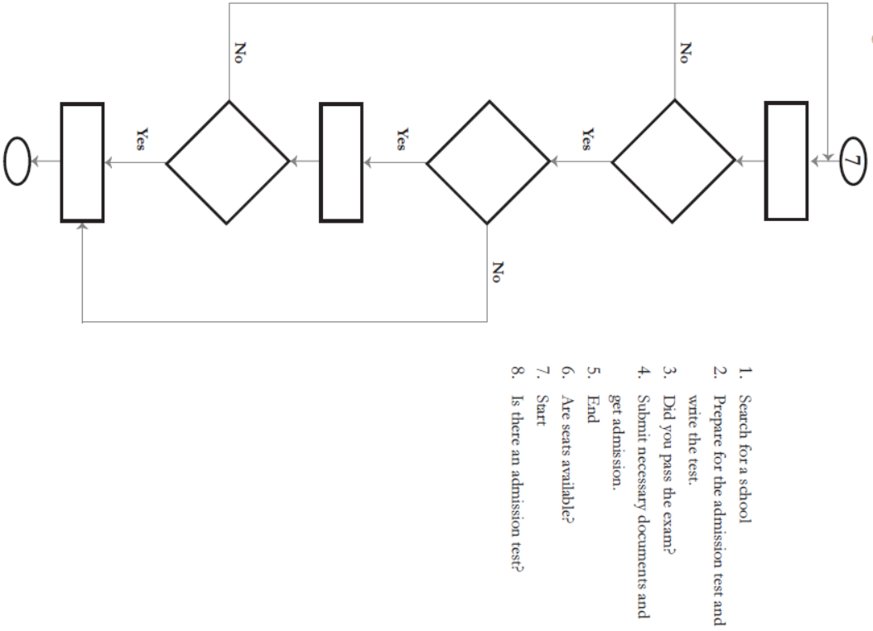

Solution
7. Start
1. Search for School [Process]
6. Are there seats available {Decision: Yes or No}
8. Is there an admission test {Decision: Yes or No }
2. Prepare for the admission test and write the test [Process]
3. Did you pass exam {Decision: Yes or No }
4. Submit necessary documentation and get admission [Process]
5. End
Exercise 9
Create a flow chart that reads in Cost Price and Selling Price. It then calculate which of them is the largest. Depending on the answer, a profit or loss is created and printed out.
CS = Cost Price
SP = Selling Price

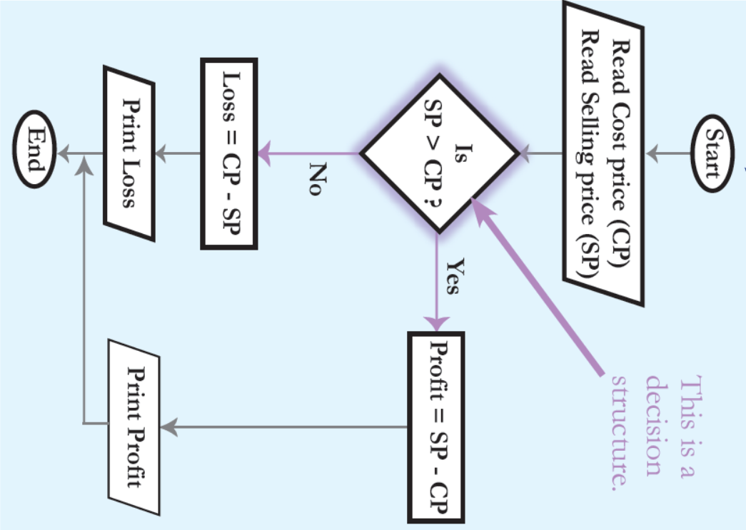

Exercise 10
Create a flow chart that asks users how many hours a week they work and how much they earn per hour. It then calculates how much money they earn a week and outputs ‘Can afford to live alone’ if earn 400 or more per week and ‘Cannot afford to live alone’ if earn less than 400.

Start

Read Hourly Pay

Read Hours Per Week

Total = Hourly Pay * Hours Per Week

Print
‘Can afford to live alone’
Is Total pay > 400

True

False
Print
‘Cannot afford to live alone’

Stop

